■ Special Edition on Car Purchase Trends
- Trends in New Car Purchasers by Age
- Purchased Car Type Trends
- Fuel Type Trends(Electronic cars, hybrids, etc)
- Car ownership trends (rent, sharing, subscription, etc)
Automotive Consumer Reports 19/20-2 ;
Booming SUVs, will it surpass the Sedan market?
- Changes in new car buyers’ age affect purchasing car types
- Small SUV is the rising star, Midsize SUV remains in its throne
- SUVs&MPVs surpassing sedan would be just a matter of time

The age of new car purchasers is going up. People in their 50s and 60s, with big pockets, want bigger, safer and more comfortable cars. Their choice was SUVs that are closely after the sedan market. Midsize SUVs have remained as the most popular car segment since 2013, and small SUVs started eroding the sedan market, pushing out small and midsize cars at the same time upon their launch. If this trend continues, SUVs & MPVs combined are possibly to exceed the sedan market in 2 to 3 years.

ConsumerInsight, an automobile research expert, has been tracking ‘the consumer trend in purchasing cars by carrying out a large-scale syndicated automobile survey every July since 2001. The surveys conducted in the past 8 years show the makeup of domestic new sedans and SUV & MPV combined as follows in Figure 1.

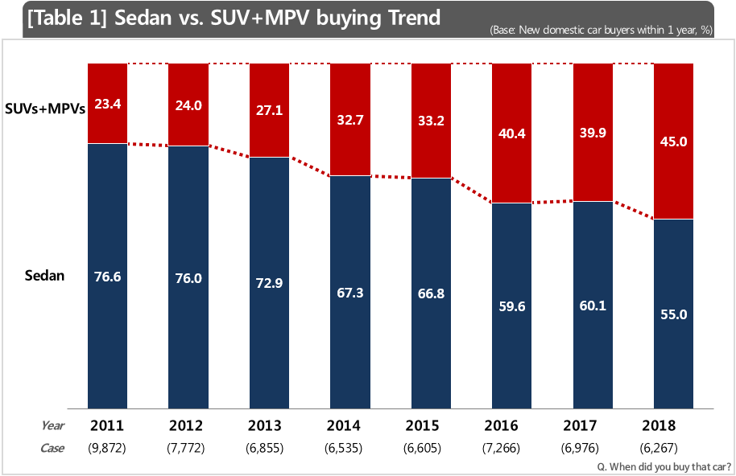
Since 2011, the proportion of sedan purchases has been steadily decreasing, while the purchase of SUVs & MPVs is increasing. The purchase gap between sedans and SUVs & MPVs was more than 3 to 1 in 2011, but the same significantly narrowed down to 10% point in 2018. (Sedan: 55.0%, SUVs & MPVs: 45.0%). It seems possible that the market of SUV & MPV combined is to exceed the sedan market in the future.
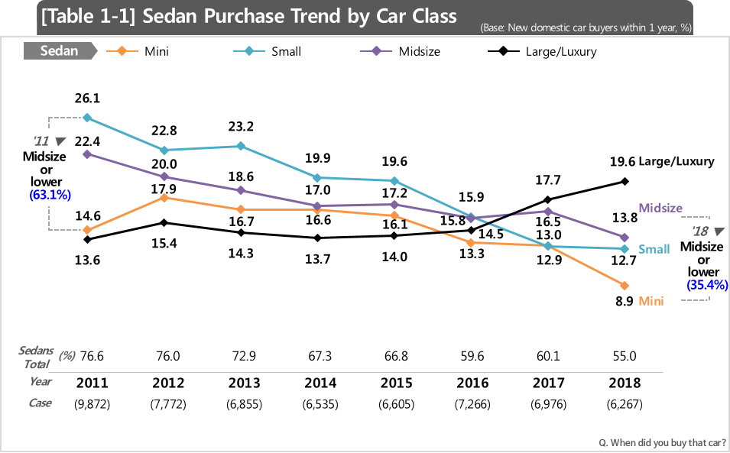
The sedan market share change by car class since 2011 shows that midsized or smaller sedans have been decreasing while large/luxury sedans have been on a rise. Midsized or smaller cars fell from 63.1% in 2011 to 35.4% in 2018, and small sedans that used to be the number one car class, with 26.1% in 2011, were cut down to 12.7% in 2018, less than the half of their market share in 2011. Large/luxury sedans that used to be the least sold (13.6%) went up to 19.6% in 2018, to become the most selling car class of the sedans. The market share of sedans was larger in the order of small, midsize, mini, large/luxury, but the order has been rearranged in the order of large/luxury, midsize, small, mini car class.

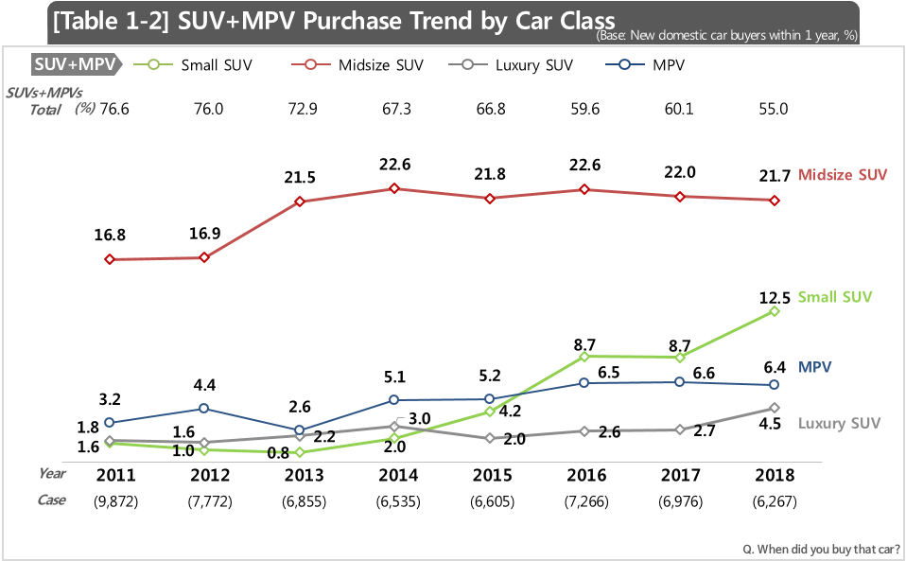
On the other hand, all the sub-segments of SUVs & MPVs have risen in market share. While midsize SUVs remained the most popular car class since 2013, small SUVs skyrocketed, replacing all of the midsize/small/mini sedans, and now inducing SUV booms. In addition, luxury SUVs (2011: 1.6%→2018: 4.5%) and MPV (2011: 1.8→2018: 6.4%) also increased, contributing to the growth of the combined SUV & MPV market.

The growth of the SUV market is closely related to changes in the age of car purchasers¹⁾. Those in their 20s and 30s that used to be the main purchase group of small cars, avoided buying cars, hurting the mini and small car segment badly. With the changes in the young generations’ lifestyles, some of them avoided buying cars, and some others moved to small SUVs. Adding to this, those in their 40s or older, the emerging car buying age groups with their big pockets, are choosing large/larger cars that are big and safe or small SUVs. As a result, it is analyzed that the growth of the SUV market is closely correlated to the increasing car buyers’ age.
The growth of the SUV market is not happening just in Korea. It is a common phenomenon all over the world, including Europe, North America, Japan and China. As a matter of fact, Ford, the American automaker, announced that it would gradually stop producing most of its sedans by 2020. Given the trend, it seems only a matter of time that SUVs outsell sedans. However, with the recently enhanced environment regulations, such various power trains as LGP/hybrid/electronic/hydrogen are being adopted, with diesel cars being blamed as the main cause of fine dusts. It is worth it to observe how the young generations’ lifestyles and environment issues will affect the SUV market.
1) 50s and 60s pushing out 20s and 30s as a big hand in the new car market (2019. 02. 19, ConsumerInsight)
(www.consumerinsight.co.kr/voc_view.aspx?no=2931&id=pr4_list&PageNo=1&schFlag=0)
==============================================================
◈ Reference: 「Consumer Insight」 Annual Automobile Syndicated Study Outline. The contents was excerpted and summarized from the results of ‘Annual Syndicated Automobile Study’ conducted by Consumer Insight Inc. in every July since 2001.
